Register page:

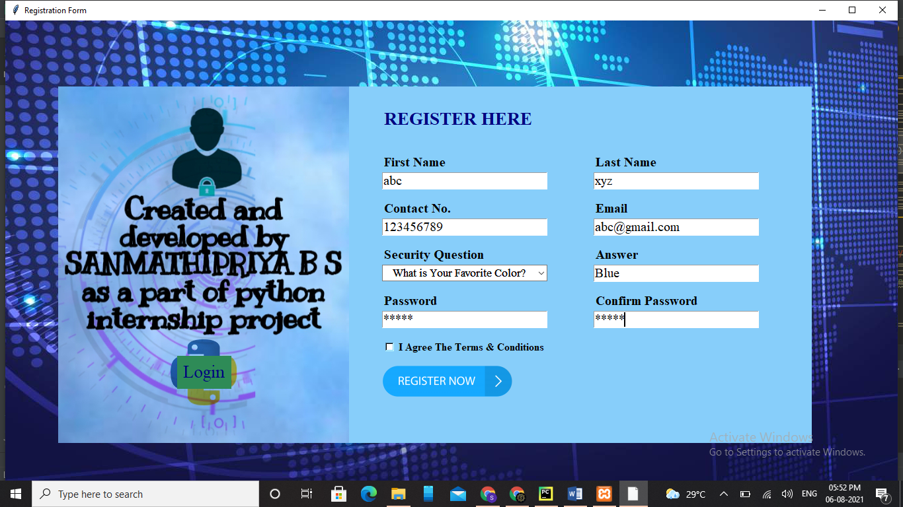

In case if you miss to fill any of the field, it throws error

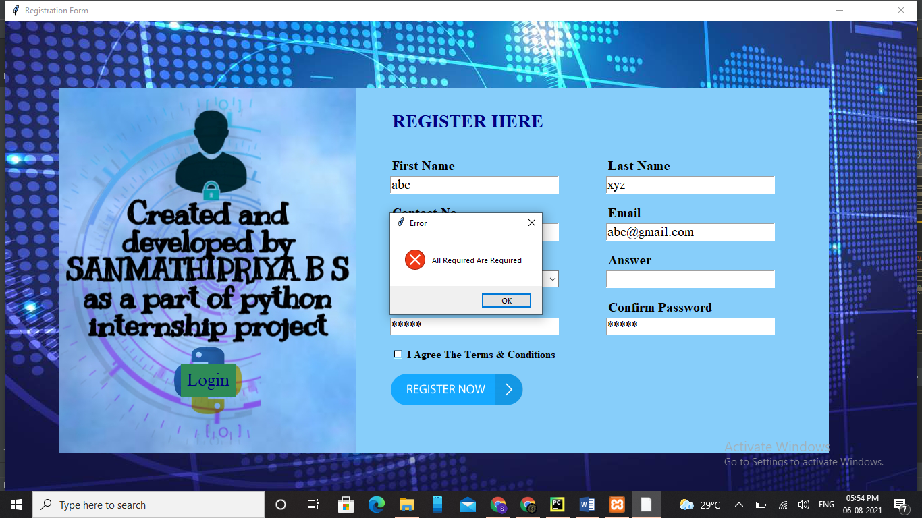

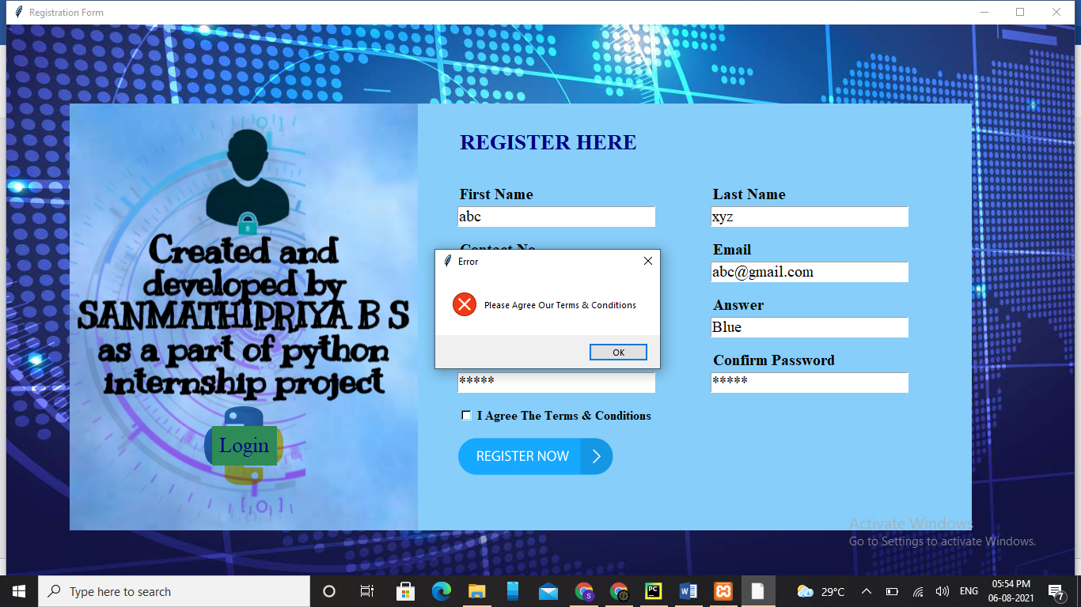

After filling all the fields once you click on register button, registration is completed and now you are ready to login

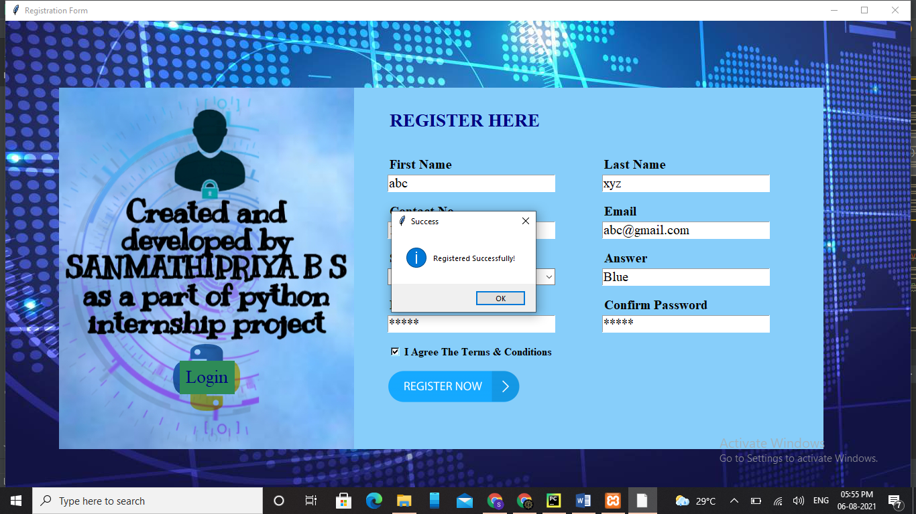

As you can see the details entered by the user while registering has been stored in MySQL database.

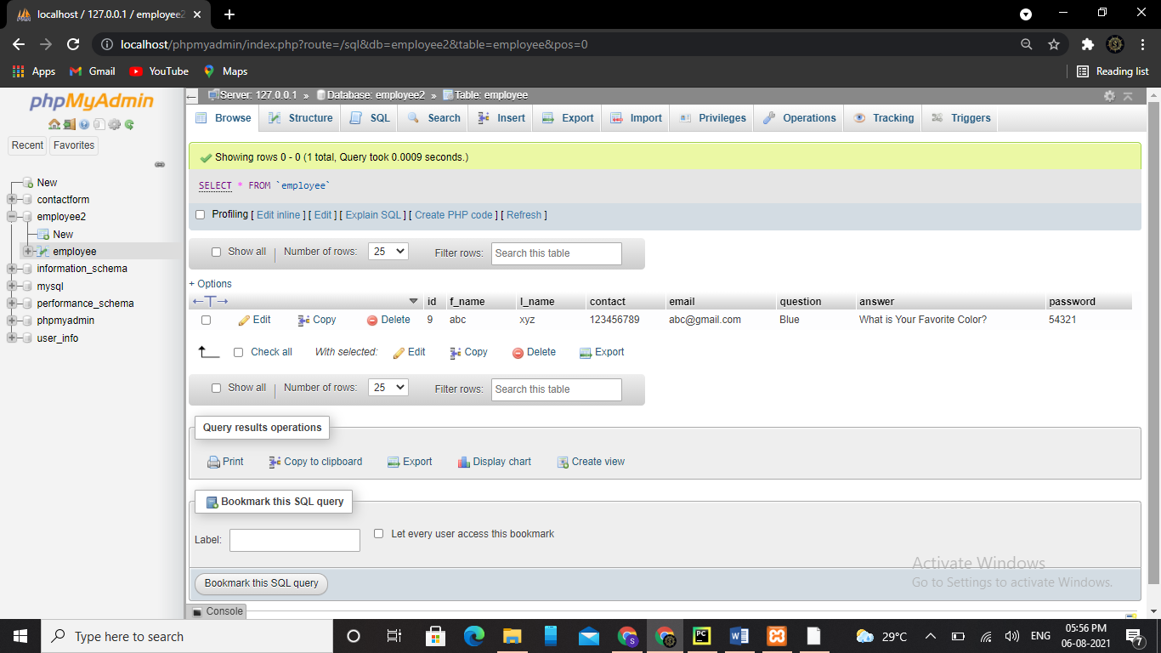

Now we will click on the login button

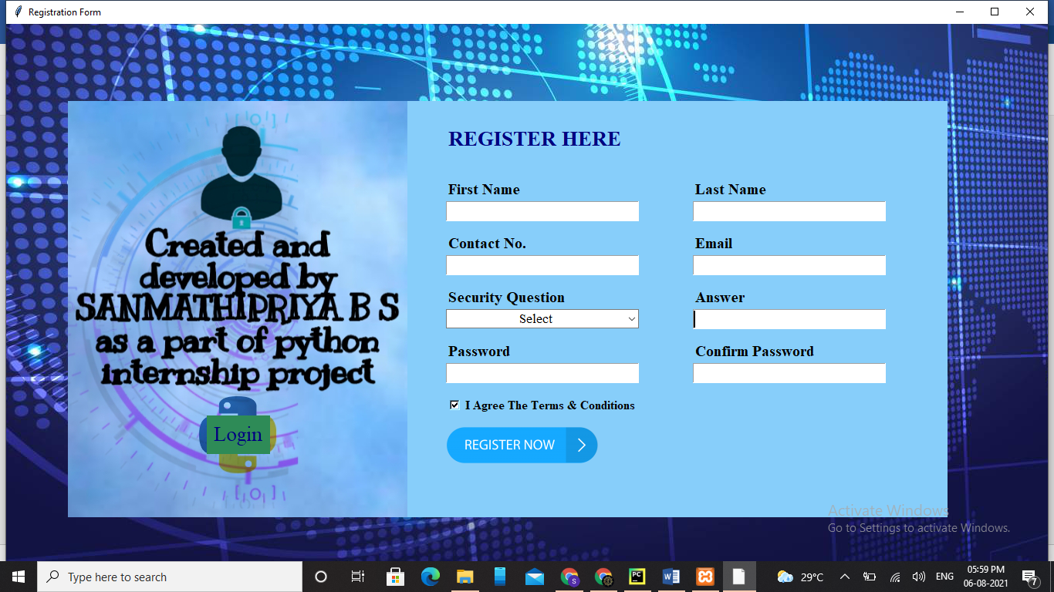

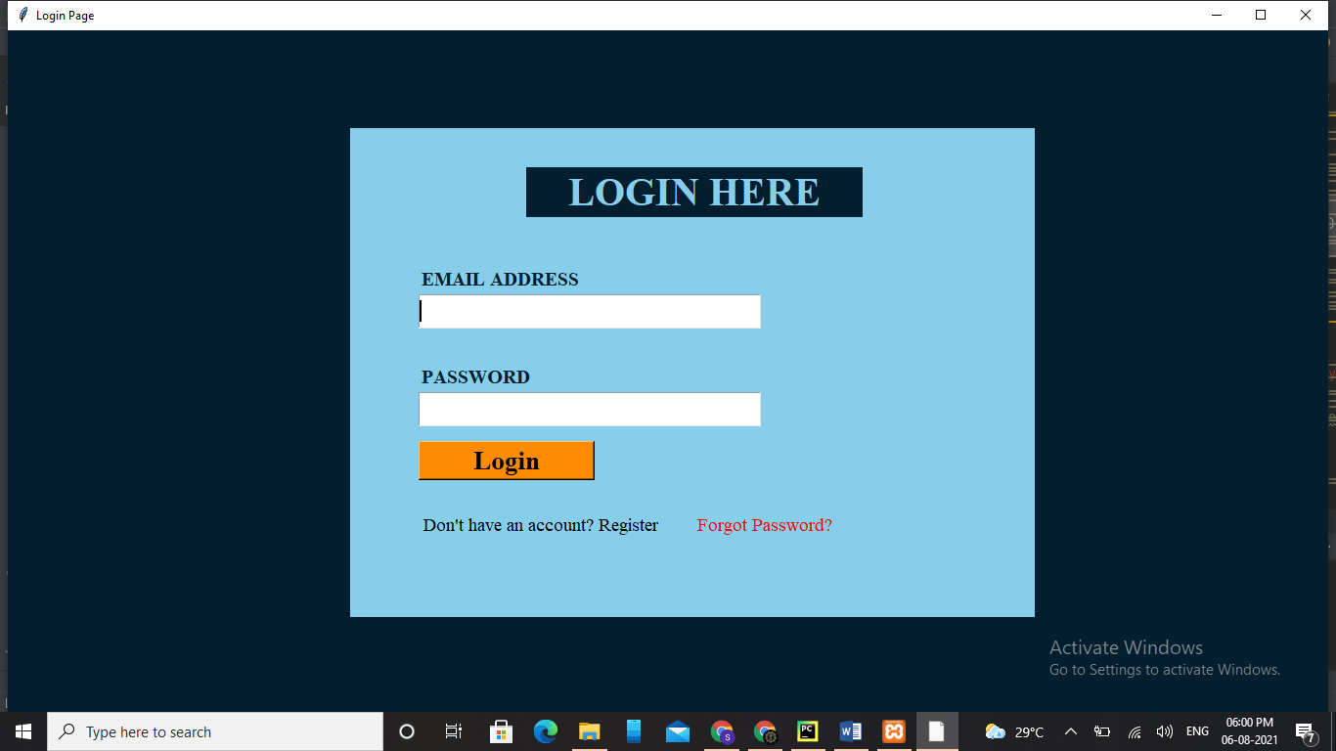

Incase if user tries to login without filling details, it throws error

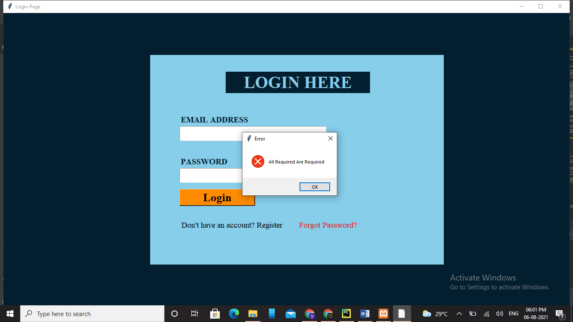

If incase user enters email id or password wrong, then it throws error

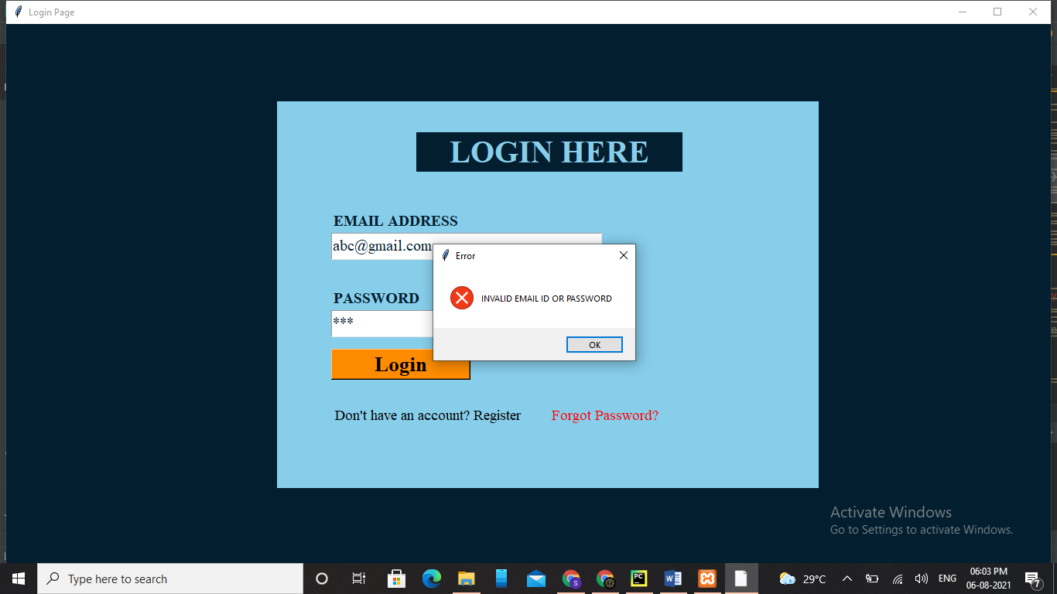

If user forgot his password, then he can click on forgot password and change it

If user clicks on forgot password without entering email then it throws error

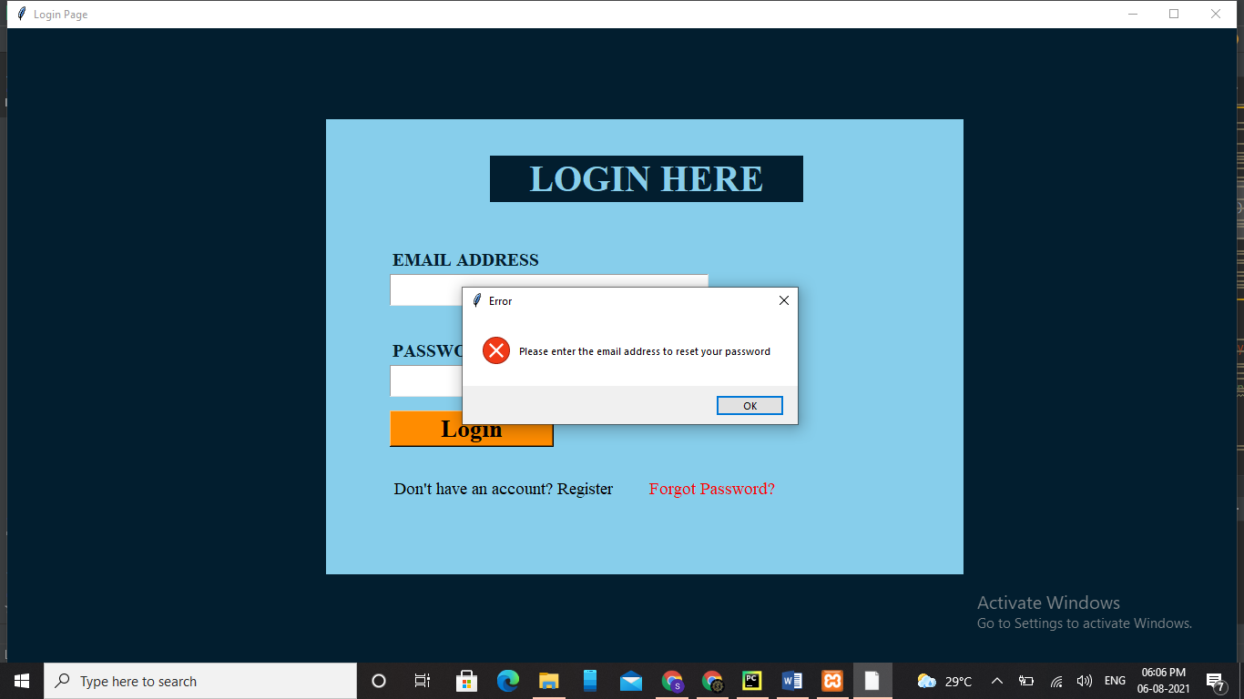

The user should first enter email id and then click on password to reset

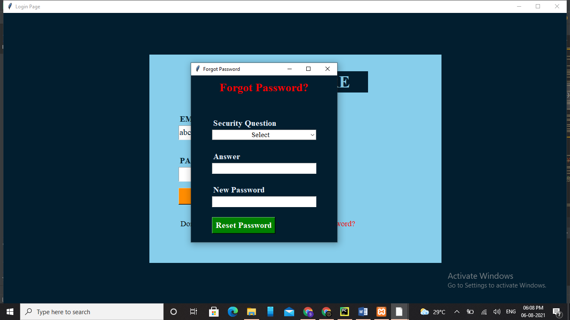

Here user can give new password and change it

After entering details, it popups success message

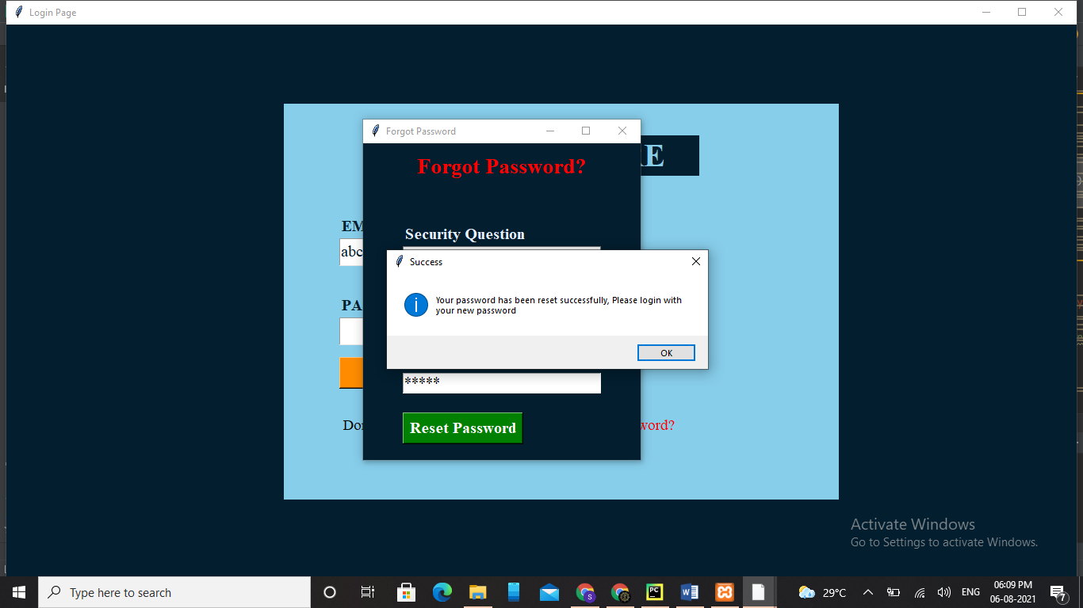

If we go back and see the database, the new password which the user has reset has been updated in the database

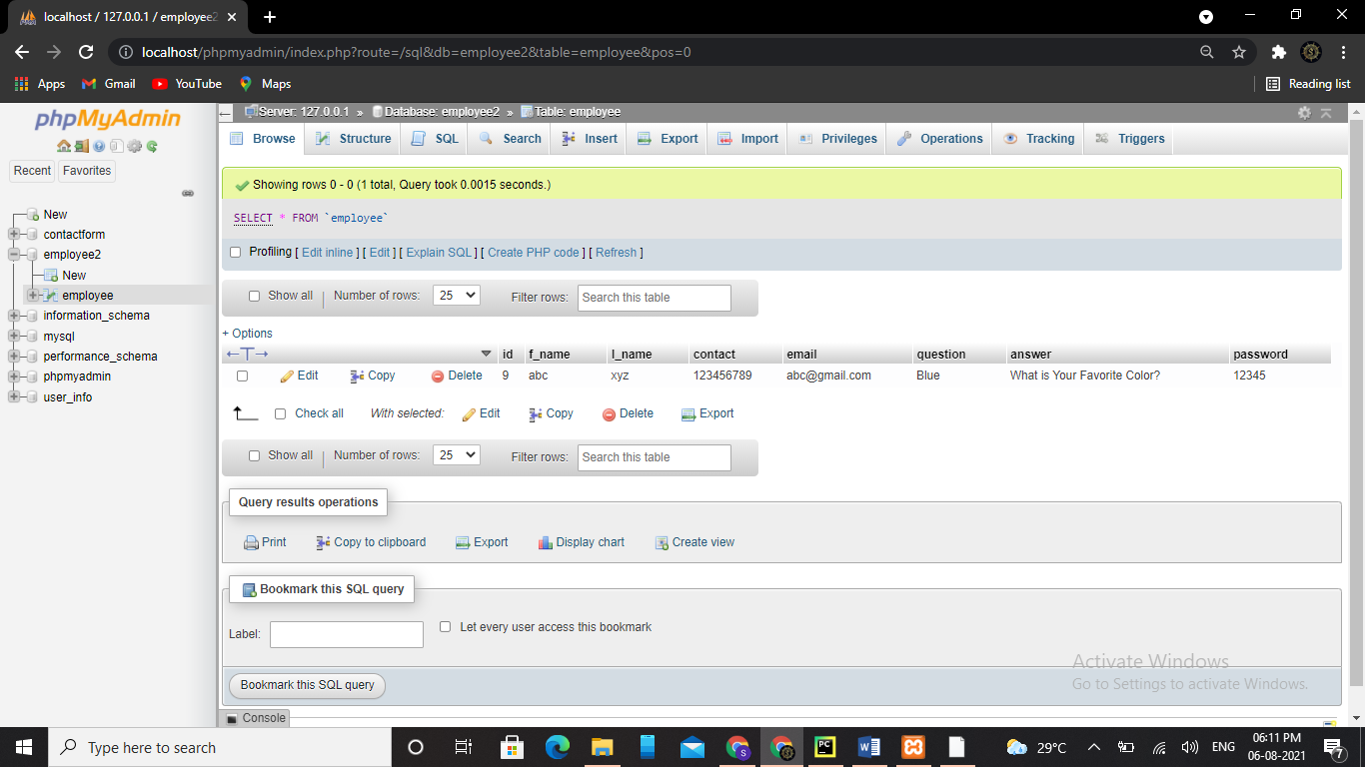

Once the user logs in, the welcome page will be displayed.

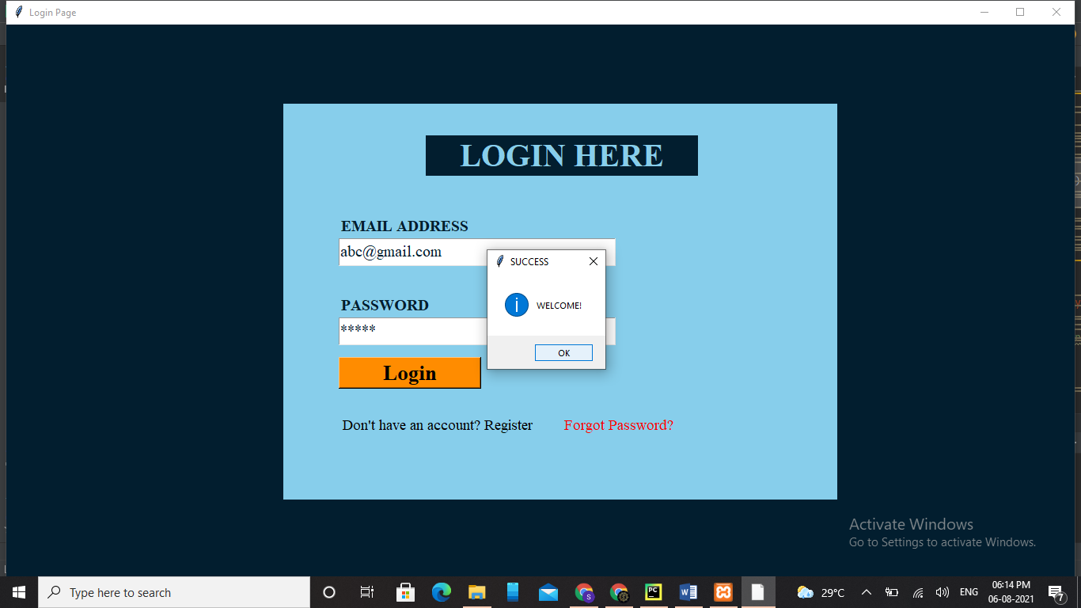



In welcome page, there are two buttons exit and back to registration. If the user clicks on back to registration page, then it redirects the user to the registration page.

If user clicks on exit button it confirms whether the user has really exit or not

